Small Nations Cup 2017
15–19 March 2017 | Republic of San Marino
BULLETIN

Small Nations Cup 2017
Dear GSSE Federations

SNC 2017 - Small Nations Cup will be held in San Marino. It is a great pleasure and honour for Sammarinese Federation to host this Small Nations Cup first time in history.

The Small Nations Cup 2017 will be held in Rose’n Bowl Bowling Center in San Marino – a very experienced bowling center hosting international events for the last 10 years.

In this bulletin, you will find the following items:
- Preliminary Schedule of Events
- Official Hotel
- Committees
- Fees
- San Marino
- Rose’n Bowl Bowling Centre
- Various information
- Forms / Deadlines

Please pay attention to the deadlines presented in this bulletin, starting with the deadline 1 December 2016 for Form A and B.

The official Web site www.smallnationscup.com will be online as soon as possible, you will al be informed at that time and it will be continuously updated with current information (there will be no more bulletins).

It is with great pleasure for us to host the delegations from the GSSE nations to this event. If you have any questions, comments or concerns please feel free to contact us via e-mail to vg@etbf.eu at any time.

Best regards
Adriano Santi
President, San Marino Federation

Preliminary Schedule of Events
Weekday | Date | From | To | Activity
Wednesday | 15.03.2017 | - | - | Team arrivals
 |  | - | - | Ball Registration
 |  | 14.00 | 20.00 | Unofficial practice

Weekday | Date | From | To | Activity
Thursday | 16.03.2017 | 08.00 | 09.00 | Lane Maintenance
 |  | 09.00 | 10.00 | Team Managers Meeting / GSSE meeting
 |  | 10.00 | 12.30 | Offical Practice + Opening/welcome
 |  | 13.00 | 14:00 | Lane Maintenance
 |  | 14.00 | 17:30 | Mixed doubles
 |  | 17:30 | 18:30 | Lane maintenance
 |  | 18:30 | 20.00 | Semi-finals + Final mixed doubles
 |  | 20.00 | 20:15 | Medal Ceremony mixed doubles

Weekday | Date | From | To | Activity
Friday | 17.03.2017 | 08.00 | 09.00 | Lane maintenance
 |  | 09.00 | 12.30 | Doubles
 |  | 12.30 | 13.30 | Lane maintenance
 |  | 13.30 | 15.00 | Semi-finals + final doubles
 |  | 15.00 | 15.30 | Medal ceremony doubles
 |  | 15.30 | 16.30 | Lane maintenance
 |  | 16.30 | 20.00 | Mix Teams 3 games

Weekday | Date | From | To | Activity
Saturday | 18.03.2016 | 08.00 | 09.00 | Lane Maintenance
 |  | 09.00 | 12.30 | Mix teams 3 games
 |  | 12.30 | 13.30 | Lane Maintenance + break
 |  | 14.00 | 16.00 | Semi-finals and finals mix teams
 |  | 16.00 | 16.30 | Medal ceremony mix teams
 |  | 16.30 | 17.30 | Lane Maintenance
 |  | 17.30 | 18.30 | Master semi-finals + finals
 |  | 18.30 | 19.00 | Medal ceremony Masters + closing

Weekday | Date | From | To | Activity
Sunday | 19.03.2017 | - | - | Departures

The Official Hotel:

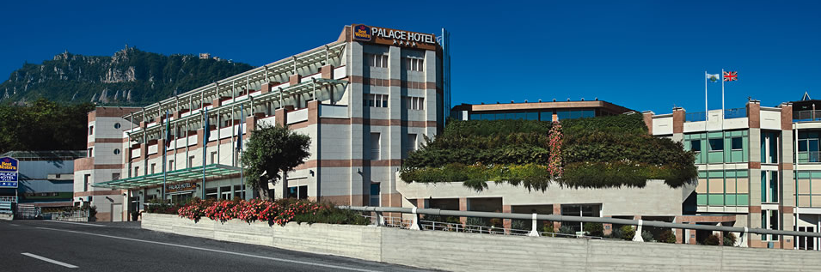 OFFICIAL HOTEL: Best Western Palace Hotel
Best Western Palace Hotel, the ideal accommodation facility for those looking for first-class services and facilities, gathers 91 bedrooms, junior suites and suites. Idyllically set along San Marino Clearway, it is situated a very short distance from both Rimini’s Riviera and the old town of the Republic. It boasts fine inner spaces, modern comforts and excellent services and facilities of a 4 start hotel.

Address of the hotel:
Via Cinque Febbraio
47899
Serravalle
Repubblica di San Marino

Website of the hotel:
http://www.palacehotelsanmarino.com/en/

Room rates:
Room rates at Palace Hotel (Comfort):
Single rooms: 72 € per night including breakfast
Double rooms: 96 € per night including breakfast

Please note that the booking should made directly to the organization in order to get the rates listed above. Please use the Form B and mail it to vg@etbf.eu

Committees

Tournament Committee
Valgeir Gudbjartsson, Tournament Director
Marios Nicolaides, Technical Delegate
Adriano Santi, President San Marino Federation.

Lane maintenance

The Pattern will be prepared by Marios Nicolaides, the length of the oil pattern will be published in due time before the beginning of the Tournament.

Fees and payments

Entry fee
The SNC 2017 entry fee is € 120 per person. This fee is payable for all delegations, including players, coaches, managers, head of delegations and other officials connected to each team.

Guest fee
The SNC 2017 guest fee is € 120 per person.
This fee is for additional guests arriving with the teams and staying at the official hotel. The fee covers full shuttle service and entrance to the centre and as well to the banquet. Such guests can not have any duties related to any team.

Payment information
All fees (including hotel accommodation) must in principle be pre-paid. The payment details are as follows, after receipt of forms A-D an Invoice will be issued and sent to each participating federation with deadline of payment:
The address of the receiver: FEDERAZIONE SAMMARINESE BOWLING
The address of the receiving bank: BSI / Banca Sammarinese di Investimento
The bank transfer information:
Account number: ECC2015
Bic Code: BSDDISMSDXXX
IBAN: SM20B0328709803000030305404

San Marino
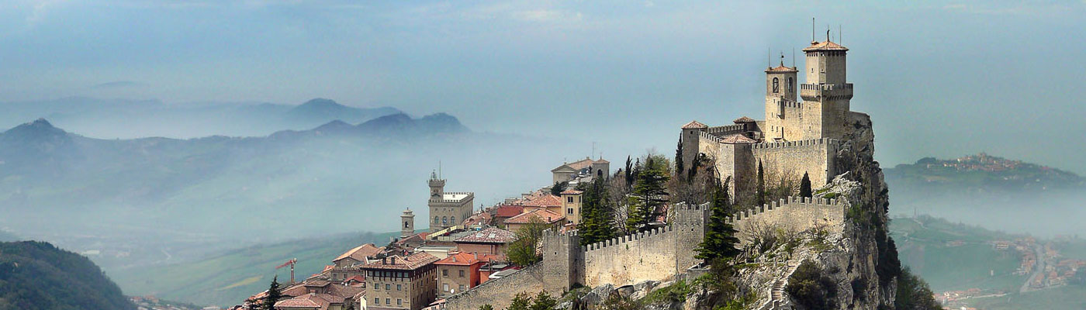
“The heart of San Marino narrates the history of a land for thousands of years suspended between earth and sky, a history packed with emotions that still continues to sustain and nurture the country’s inhabitants and traditions.”

San Marino is the world's oldest republic and Europe's third smallest state. It lies 657 m above sea level with spectacular views of the surrounding countryside and Adriatic coast, and is situated only 10km from Rimini. Legend has it that the founder of San Marino, a stonemason arrived from the island of Rab in Dalmatia, climbed Mt. Titano to found a small community of Christians, persecuted for their faith by the Emperor Diocletian.
San Marino is made up of a few towns dotted around the mountain sides. The capital of San Marino is itself called 'San Marino' and is situated high up on a mountain top. The capital is surrounded by a wall and three distinct towers overlook the rest of the country. The site "San Marino: Historic Centre and Mount Titano" has become part of the UNESCO World Heritage List in 2008. Please check http://www.visitsanmarino.com for more information about San Marino
How to reach San Marino

The Republic of San Marino is located in Central Italy, 10 km far from the Adriatic Sea; only road connections with Italy.

BY CAR
Motorway A14 Bologna-Ancona; Rimini Sud exit - Dual Carriageway Rimini-San Marino SS72
Motorway A14 Bologna-Ancona; Rimini Nord exit - SP “Marecchiese” n° 258

BY PLANE
Bologna Airport "G. Marconi"
132 km - www.bologna-airport.it

BY TRAIN
Rimini Railway Station

Bowling Center: Rose’n Bowl
Rose’n Bowl is a well-known tournament venue in European Tour (Host of 12 year old San Marino Open EBT Stop) and various San Marino/Italian events. With its great designed interior design and facilities it provides a comfortable and enjoyable experience to competitors.
The center is also famous of their Pub “Rose’n Pub”, which provides a great selection of food and beverages form Italian and International cuisines.

Address and location
Strada Bulumina 3
Serravalle
San Marino
Phone: +378 549 888 840
Fax: +378 549 888 842
Website: www.rosenbowl.com

Technical specifications
Number of lanes: 18
Lane approach: Synthetic Texture System 300
Lane surface: Synthetic System 300
Pin decks: System 300
Pinsetters: VIA
Pins: Diamond Duramid 300
Score system: Steltronic

The length of the oil pattern / Dressing specifications
The length of the oil pattern will be published in due time before the beginning of the championships.

Other Information
Web Site
The official website of the SNC 2017 is www.smallnationscup.com, it is not online yet, but it will be informed to all when it is up and running, it will be continuously updated with all information concerning the championships. Please note that there will be no bulletins after Bulletin I.
Results
All game by game results and standings will be provided and will be published online over our web site.
Shuttle (Airport, Hotel, Bowling Centre)
All delegations will be met at the airport upon arrival and will be transported to the official hotel. A similar delivery service will be provided for the departures. Federations must provide their flight arrival and departure times with form D to make this service work properly.
A shuttle bus service between the official hotel and the bowling centre will be provided to all players, coaches, officials and supports with an official entry.
Please understand that we will not be able to provide airport transfers or shuttle services for teams arriving before 15 March or leaving after 19 March
Equipment Storage
Bowling equipment will be stored in a designated area at the bowling centre.
Proshop
Bowling Center has a very active and well equipped IBPSIA certified Proshop to help bowlers/coaches. Resurfacing hardware will be provided for the bowlers/coaches during the event.
Farewell banquet
The farewell banquet will be held on 18 March 2017 at 20:00 at Best Western Palace Hotel - the banquet will be complimentary for all players and members of the official delegations with a valid entry.

Bus services
All delegations not using other means of transportation and accommodated at the official hotel, will be met at the airport, and transferred by bus/minibus/car to hotel/bowling centre. All bowling equipment will be taken care of and transported from the airport to the bowling centre.
A scheduled shuttle service hotel-centre-hotel will be provided for all players, coaches, officials and registered guests staying at the official hotel.
In addition, there will be mini busses available for various situations.

Registration
It is very important that each team manager turns up for a team registration in the centre soonest possible after arrival. During the registration, we will validate the names of players, the nationality of the players, and all payments.
The sooner all teams complete their registration; the sooner we can publish the lane assignments.

National anthems
All necessary national anthems will be picked from the ETBF website.

Forms and deadlines
Attached to this bulletin are the forms related to the SNC 2017
We hope for your understanding of the necessity of enforcing the presented deadlines. It is in all aspects for the benefit of the teams, all present officials and the whole organisation that we are as well prepared as possible.

Form A: Entry form
The deadline for Form A to be submitted is 1 December 2016
Federations, sending the Entry Form later than 1 December will not have their teams included in the Small Nations Cup 2017.

Form B: Hotel Form
The deadline for form B to be submitted is 1 December 2016.
Federations sending the Hotel Form later than 1 December 2017 cannot expect accommodation at the official hotel, cannot expect to benefit from the special room rates and will not be able to benefit from the provided shuttle service.

Form C: Room list with names
The deadline for Form C to be submitted is 31 January 2017.

Form D: Arrival and departure
The deadline for Form D to be submitted is 31 January 2017.

Form E: Names in delegation
The deadline for Form E to be submitted is 31 January 2017.

Form F: List of guests
The deadline for form F to be submitted is 31 January 2017

Form A: Entry Form
Please return this form even if you do not want to participate in the SNC 2017
Federation

Confirmation
We want to participate (Yes/No)

The delegation
Number of female players
Number of male players
Number of coaches and officials
Number of guests

Contact information
Contact person
Address
Phone
Mobile
Email

The ultimate deadline of submitting this form is 1 December 2016
Your contact person is Valgeir Gudbjartsson
Phone | Mobile | Email
+354 843 3054 | +354 843 3054 | vg@etbf.eu
Form B: Hotel Form
Booking at this hotel includes free access to the hourly shuttle service hotel-centre-hotel
Federation

Are using another accommodation?

Number of rooms | Type of rooms | Arrival date | Departure date
For the second column in the table above, please use one of the following codes:
1 for a single room, 2 for a double room.
Only bookings directly to the organisation, not to the hotel, will be accepted.

The ultimate deadline of submitting this form is 1 December 2016
Your contact person is Valgeir Guðbjartsson
Phone | Mobile | Email
+354 843 3054 | +354 843 3054 | vg@etbf.eu

Form C: Room list with names
Federation

Your delegation divided at the hotel rooms
Room | Type | Please type all names at the room (in order: first name, surname)
1
2
3
4
5
6
7
8
9
10
11
12
For the second column in the table above, please use one of the following codes:
1 for a single room - 2 for a double room
The ultimate deadline of submitting this form is 31 January 2017
Your contact person is Valgeir Gudbjartsson
Phone | Mobile | Email
+354 843 3054 | +354 843 3054 | vg@etbf.eu

Form D: Arrival and departure
Federation

Mean of transportation
Will arrive by flight – yes/no – if no then how

Arrival information
Number of people
Date and time in digital presentation
Flight no.

Departure information
Number of people
Date and time in digital presentation
Flight no

The ultimate deadline of submitting this form is 31 January 2017
Your contact person is Valgeir Gudbjartsson
Phone | Mobile | Email
+354 843 3054 | +354 843 3054 | vg@etbf.eu

Form E: Names in delegation
Federation

Players
Name | Function
 | Male player
 | Male player
 | Female player
 | Female player

Officials
Name | Function

The ultimate deadline of submitting this form is 31 January 2017
Your contact person is Valgeir Gudbjartsson
Phone | Mobile | Email
+354 843 3054 | +354 843 3054 | vg@etbf.eu

Form F: List of guests
Federation

Name

The ultimate deadline of submitting this form is 31 January 2017
Your contact person is Valgeir Gudbjartsson
Phone | Mobile | Email
+354 843 3054 | +354 843 3054 | vg@etbf.eu

